Week-5
Q1: What are the key limitations of traditional MapReduce that make Spark a preferred choice for modern big data processing?
ANS:
Key limitations of traditional MapReduce that make Spark a preferred choice for modern big data processing are as followings:
Disk I/O Bottlenecks: MapReduce writes intermediate results to disk (HDFS) after every map and reduce phase, causing heavy disk I/O and latency. Spark processes data in-memory (RAM), making it up to 100x faster.
Complex Data Flows: MapReduce only supports Map and Reduce operations, making multi-stage workflows cumbersome. Spark supports rich DAGs (Directed Acyclic Graphs) with various transformations.
Unsuited for Interactive/Iterative Processing: Iterative workloads (like ML algorithms or graph processing) are extremely slow in MapReduce due to constant re-reading/re-writing to disk.

Q2: Explain how Spark uses In-Memory Computing to speed up iterative machine learning algorithms compared to disk-based systems.
ANS:
Spark uses In-Memory Computing to speed up iterative machine learning algorithms compared to disk-based systems.
Iterative ML algorithms (e.g., Gradient Descent, K-Means) process the same dataset repeatedly across multiple iterations:
- Disk-Based Systems (MapReduce): Each iteration reads data from disk, computes, and writes results back to disk, creating massive I/O overhead.
- Spark In-Memory: Spark allows datasets to be cached/persisted in RAM across iterations (df.cache() or df.persist()). Subsequent iterations reuse the cached memory directly, drastically reducing execution time.
Q3: Write a code snippet to remove all duplicate rows from a DataFrame based on a specific set of columns: user_id and transaction_date.
QUERY:
df_cleaned = df.dropDuplicates(["user_id", "transaction_date"])
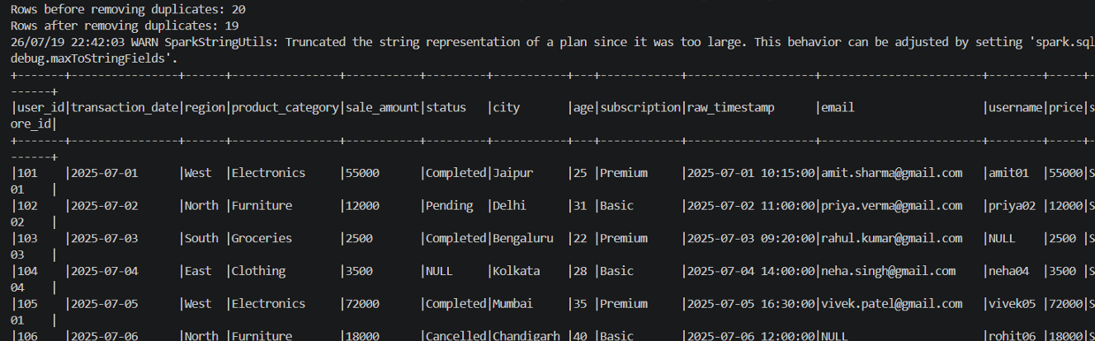
Q4: Given a DataFrame df_sales, write a query to filter for rows where the region is 'West' and then group by product_category to find the average sale_amount.
QUERY:
from pyspark.sql.functions import avg

df_result = (
df_sales.filter(df_sales["region"] == "West")
.groupBy("product_category")
.agg(avg("sale_amount").alias("avg_sale_amount"))
)
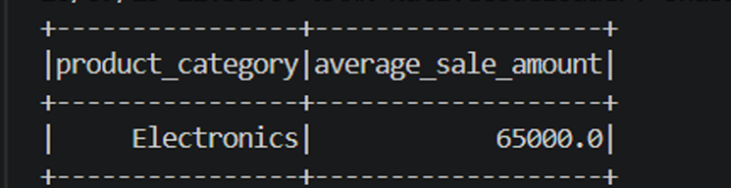

Q5: What is the difference between .na.drop() and .na.fill()? Provide a code example of filling null values in a status column with the string 'Unknown'.
ANS:
The difference between .na.drop() and .na.fill() is:
.na.drop(): Removes rows containing null (or NaN) values from the DataFrame.
.na.fill(): Replaces null values with a specified default value across specified or all columns.
QUERY:
df_filled = df.na.fill({"status": "Unknown"})

Q6: Write a query to find the total count of records for each city in a DataFrame, but only for cities where the count is greater than 100.
QUERY:
from pyspark.sql.functions import count
df_city_counts = (
df.groupBy("city")
.agg(count("*").alias("city_count"))
.filter("city_count > 100")
)
My sample dataset contains only 20 records, so no city has more than 100 records. Therefore, the query returns an empty result.
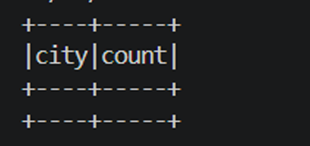
Q7: How does the immutability of Spark DataFrames affect how you perform "data cleaning" steps like dropping columns or renaming them?
ANS:
Spark DataFrames are immutable, we cannot modify an existing DataFrame in place.
When you perform data cleaning operations (like dropping columns or renaming them), Spark produces a new DataFrame representing the transformed logical plan. Under the hood, Spark constructs a Directed Acyclic Graph (DAG) and defers execution until an action (e.g., .show(), .count(), .write()) is invoked.
Q8: Write a Spark command to filter a dataset for rows where the age is between 18 and 30 (inclusive) and the subscription is 'Premium'.
QUERY:
df_filtered = df.filter(
(df["age"] >= 18)
& (df["age"] <= 30)
& (df["subscription"] == "Premium")
)
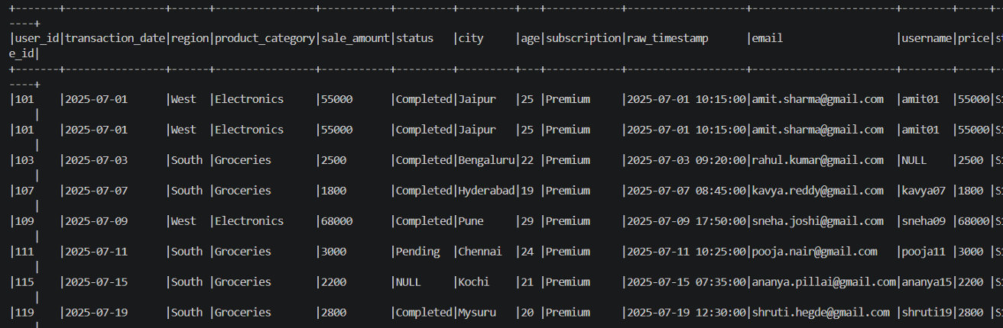
Q9: When cleaning a dataset, why is it often better to handle null values before performing mathematical aggregations like sum() or avg()?
ANS:
When cleaning a dataset it is often better to handle null values before performing mathematical aggregations like sum() or avg()because:
Data Integrity & Consistency: Null values can lead to silent discrepancies in mathematical computations or missing metrics depending on how underlying functions handle them.
Avoiding Unexpected Null Outputs: In certain expressions or custom logic, unexpected null values can propagate through operations, producing null output for entire calculations.
Predictable Grouping: Pre-cleaning nulls (e.g., replacing missing numeric values with 0 or baseline defaults) ensures that aggregations operate strictly on valid, predictable domain ranges.

Q10: Write the code to revise a column named raw_timestamp by casting it to a TimestampType and renaming it to event_time.
QUERY:
from pyspark.sql.functions import col
from pyspark.sql.types import TimestampType
df_updated = df.withColumn(
"raw_timestamp", col("raw_timestamp").cast(TimestampType())
).withColumnRenamed("raw_timestamp", "event_time")
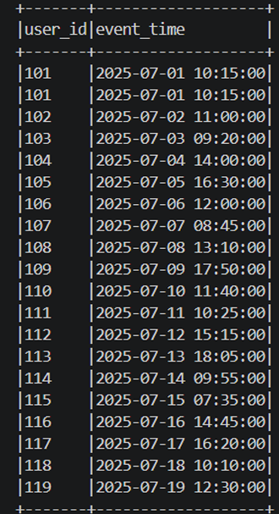
Q11: Explain the "Shuffle" process that occurs during a grouping operation. Why is it considered a wide transformation?
ANS:
Shuffle: The process of redistributing data across multiple cluster nodes/partitions so that rows sharing the same key (e.g., the same groupBy key) end up on the exact same physical executor node.
Unlike narrow transformations , where each partition can be processed independently without network communication, wide transformations require data exchange across network boundaries (all-to-all partition exchange), making them performance-intensive.

Q12: Write a code snippet that identifies and removes rows where the email column contains null values OR the username is an empty string.
QUERY:
from pyspark.sql.functions import col
df_cleaned = df.filter(
col("email").isNotNull() & (col("username") != "") & col("username").isNotNull()
)
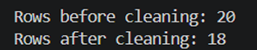
Q13: How do you use the .agg() function to calculate multiple statistics at once, such as the min, max, and mean of the price column?
QUERY:
from pyspark.sql.functions import avg, max, min
df_stats = df.agg(
min("price").alias("min_price"),
max("price").alias("max_price"),
avg("price").alias("avg_price"),
)
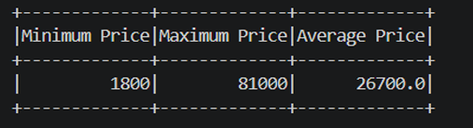
Q14: In the context of cleaning a dataset, what is the risk of using inferSchema=true when your source data contains messy or inconsistent date formats?
ANS:
The risk of using inferSchema=true when your source data contains messy or inconsistent date formats:
Incorrect Data Type Casting: If a date column contains inconsistent strings or malformed records, Spark may fail to recognize it as a date and default to casting it as a StringType.
Silent Errors / Partial Nulls: During parsing, invalid date strings may silently evaluate to null, leading to subtle data loss without triggering immediate schema errors.
Performance Impact: inferSchema requires an extra full pass over the dataset to scan data types, slowing down pipeline initialization on large files.

Q15: Write a final processing pipeline that:
- Filters out duplicates.
- Fills null prices with 0.
- Groups by store_id to calculate total revenue.
QUERY:
from pyspark.sql.functions import col, sum as _sum
pipeline_result = (
df.dropDuplicates()
.na.fill({"price": 0})
.groupBy("store_id")
.agg(_sum("price").alias("total_revenue"))
)
The pipeline first removes duplicate records to avoid counting the same transaction multiple times. It then replaces missing prices with 0 to ensure accurate calculations. Finally, the data is grouped by store_id to calculate the total revenue for each store.
